PRACTICE TEST 1

Question 1. Given a database as follows.

Customers(CustomerID, company_name, Caddress, email)
Products(ProductID, name, SupplierID, Pquantity, unit, price)
Suppliers(SupplierID, SupplierName, Saddress, tel)
Employee(EmpID, EmpName, dateofbirth, startdate, Eaddress, salary, allowance)
Orders(OrderID, CustomerID, EmpID, orderdate, deliverdate, receivedate, deliver_location)
Invoice(OrderID, ProductID, price, quantity)

Write each of the following queries in SQL.
- Display the ID and name of products whose prices are higher than 10 and quantities are fewer than 20.
- Display all information of customers whose ordered Viettien shirts.
- Display all information of products which have not been ordered.
- Show the sold quantity of each product.
- Display the information of employees whose have the same birthday.
- For each employee, count the numbers of invoices they made.

Question 2. We would like to design a database to maintain information about hospital staff, including doctors and nurses, and patients at the hospital. The information we need includes:
- Staff, including their names, addresses and social-security numbers.
- Patients, including their names, addresses, and the name of their insurance company.
- Patients are each assigned to a ward (room).
- Those staff who are nurses are assigned to zero or more wards. Each ward has at least one nurse assigned.
- Those staff who are doctors are assigned to zero or more patients. Patients may or may not have a doctor assigned, and they may have more than one doctor. Patients in the same ward may have different doctors but will always have the same nurse(s).
- Design and draw an ER diagram for the schema. Specify key attributes of each entity type, and structural constraints on each relationship type. Note any unspecified requirements and make appropriate assumptions to make the specification complete. (2 points)
- Translate the ER diagram into relational model. Please remember to assign keys for every relation. (1 point)

Question 3. Consider a relation R = (U, F) with
U= CRHTSG ( C : Course, T : Teacher, H Hour, R : Room, S : Student, G :Group)
F ={C ->T , HR -> C, CH -> R, CS->G, HS->R}

- Find all the candidate keys of R.
- Find a minimum cover of the set of functional dependencies F.
- Identifies the best normal form that R satisfies.
- Decompose R into a set of BCNF relations

PRACTICE TEST 2
Question 1. Convert the following ER diagram into relational database
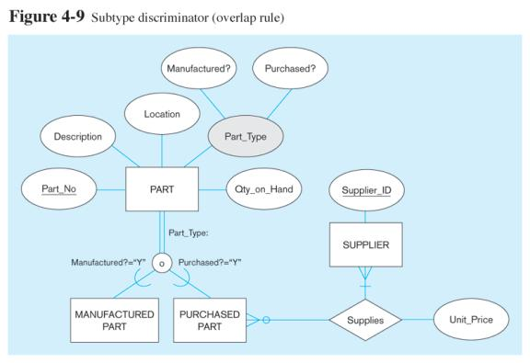

Question 2. Consider a relation R(U,F) with
U = (ABCDEFGHIJ)
G = {AB->CI, BD->EF, C->HI, AD->GH, A->I, H->J}
- Find all the candidate keys of R.
- Find a minimum cover of the set of functional dependencies G.
- Identifies the best normal form that R satisfies.
- Decompose R into a set of 3NF relations.
- Decompose R into a set of BCNF relations.

-----THE END-----

